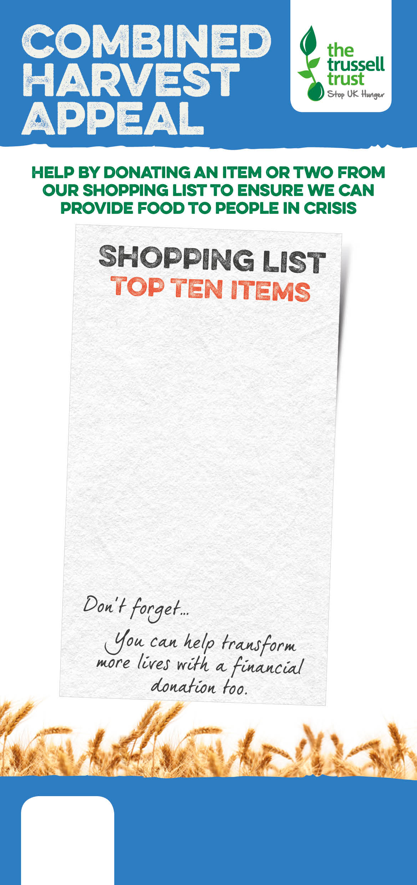  







Salisbury Foodbank

salisbury.foodbank.org.uk

Registered Charity in England & Wales (1110522)

Registered Charity in Scotland (SC044246)

)

Salisbury Foodbank

salisbury.foodbank.org.uk

Registered Charity in England & Wales (1110522)

Registered Charity in Scotland (SC044246)

)

Registered Charity in England & Wales (1110522)

Registered Charity in Scotland (SC044246)

Salisbury Foodbank

salisbury.foodbank.org.uk

tinned fish

instant coffee  
tinned meat  
cup-a-soup

tinned rice pudding

biscuits

tinned meals

long life fruit juice

bar of chocolate   
shampoo, deodorant

tinned fish

instant coffee  
tinned meat  
cup-a-soup

tinned rice pudding

biscuits

tinned meals

snacks

bar of chocolate   
shampoo, shower gel

tinned fish

instant coffee  
tinned meat  
cup-a-soup

tinned rice pudding

biscuits

tinned meals

long life fruit juice

bar of chocolate   
shampoo, deodorant