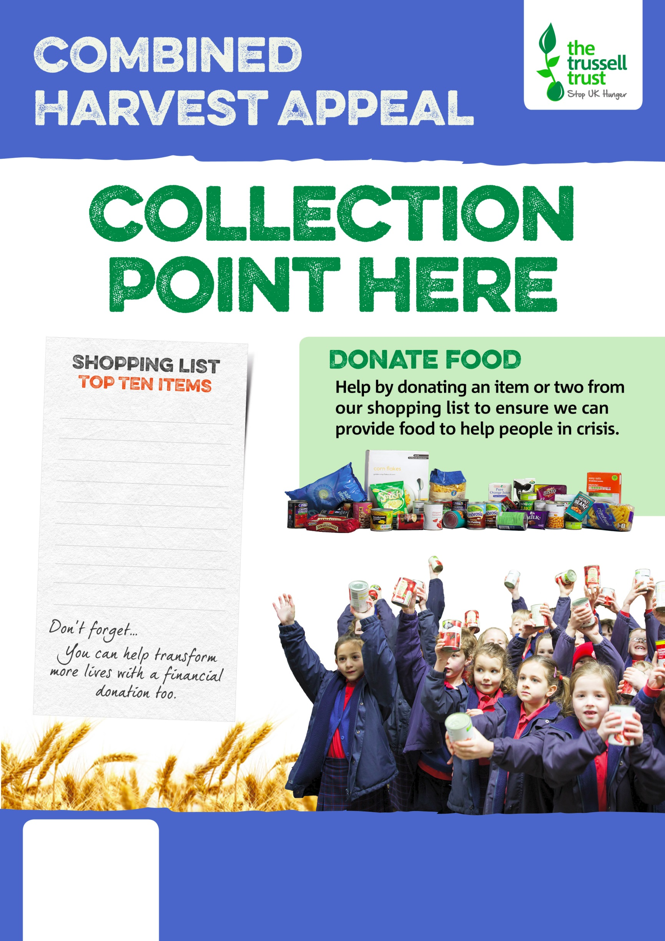

tinned fish

instant coffee  
tinned meat  
cup-a-soup

tinned rice pudding

biscuits

tinned meals

long life fruit juice

bar of chocolate   
shampoo, deodorant



Salisbury Foodbank

salisbury.foodbank.org.uk

Registered Charity in England & Wales (1110522)

Registered Charity in Scotland (SC044256)