INFORMATION PACK FOR TRUSTEE APPLICANTS – BOARD OF TRUSTEES

As a trustee, you will do all you can to further Salisbury Foodbank’s Charitable Objects. The objects of the CIO are the relief of those in Salisbury and the surrounding areas who are in need by reason of financial hardship by:
- providing or arranging for the provision of food, toiletries and other essential household items to individuals and families
- helping individuals and their families to access information and other advisory services relevant to their needs and
- such other means as the trustees may from time to time think fit.

You will find the specific duties of the Trustees outlined in the Role Profile available to download from the Salisbury Foodbank website, https://salisbury.foodbank.org.uk

Time Commitment
You will need to be able to commit to a minimum of 6 full trustees meetings a year, which are held in the evenings as well as the planning and liaison required ahead of each meeting. There will also be the occasional need to oversee or be involved in special projects and sub-committees on an ad hoc basis.
All trustees are asked to attend events to promote the work of Salisbury Foodbank as well as making visits on appointment to the warehouse to familiarise themselves with its operation.
The Trussell Trust Foodbank Network
Salisbury Foodbank is a member of the Trussell Trust's Foodbank Network under a franchise agreement and receives support from them in the form of policies, practices and access to the Data Collection System. Some of its Operations team are also available for help and advice. Trustees are invited to regular regional network events organised by the Trussell Trust which look at key area of interest to all.

The Trussell Trust is a charity founded on and shaped by Christian principles and all members of its network welcome applications from people of all faiths and none.

Background information about Salisbury Foodbank

History
Salisbury foodbank was opened in 2000 as part of a small charity run from the city founded in 1997 to support street children in Bulgaria. It was set up by former Army officer Paddy Henderson and his wife Carol with a small legacy from Carol’s mother, Betty Trussell.
The Trussell Trust expanded its network of food banks to the current 428 during the period 2009-2014 responding to the high demand for services during a period of financial crisis. Most of these foodbanks were run by church and community groups and were set up as independent charities but part of the Trussell Trust umbrella foodbank network. Many of them were set up as purely temporary measures responding to local needs at the time.

Independent status
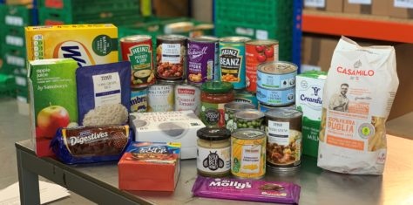
In November 2020, Salisbury Foodbank left management by the Trussell Trust and was set up as an independent charity registered with the Charity Commission (reg no 1190323) with its own board of trustees and responsibility for income generation. It currently employs four part-time staff (manager, admin assistant, foodbank centres manager and donor admin) with all other functions such as warehouse operations, donation sorting and food parcel distribution undertaken by c 50 active volunteers. We operate from a leased warehouse in Ashfield Road Trading Estate in Salisbury. We are still part of the Trussell Trust Foodbank Network and receive support and assistance from them.

How Salisbury Foodbank works
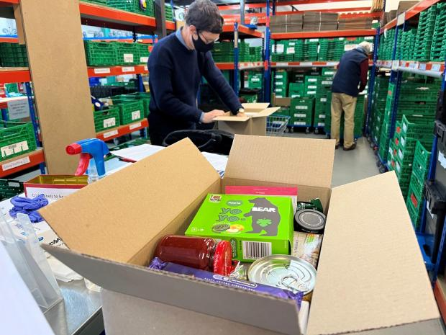
Food donations are collected by community groups, in churches and from permanent collection points in local Tesco stores as well as some branches of Waitrose. Ad hoc donations can also come from local food retailers and national producers (the latter via the Trussell Trust) as well as two regular 3-day in store collections in local branches of Tesco.

These donations are then sorted in our warehouse into food boxes containing three days of nutritionally-balanced ambient food as well as some toiletries, household cleaning products and pet food. Boxes are made up according to family size and dietary requirements. (We are also able to deliver fresh fruit and vegetable boxes directly to foodbank users on request in partnership with a local supplier.)

The boxes are then distributed by volunteers from seven distribution centres in south Wiltshire. People are referred to the foodbank by a variety of local agencies such as social services, schools, GPs, the police and other local welfare agencies and charities. At the centres, people who visit to collect food are greeted in a friendly atmosphere by volunteers who will aim to have a conversation about their circumstances so that we can check that they are able to access all the help they are entitled to or refer them on to other agencies for further assistance if necessary. Unfortunately though, many people have come to the foodbank as a last resort. Food boxes are also held for emergency support in some local GP surgeries, schools and hospitals.

How many people do we help?
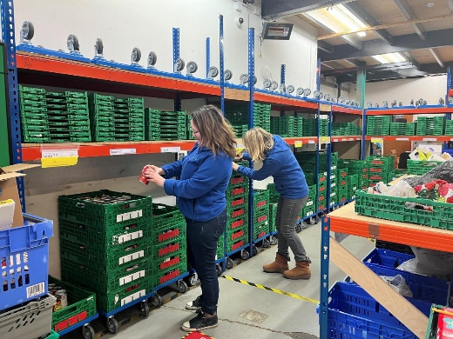
Between 1 April 2022 and 31 March 2023, food banks in the Trussell Trust’s UK wide network distributed close to 3 million emergency food parcels to people facing hardship – this is an increase of 37% from the same period last year. More than one million of these parcels were distributed for children. Salisbury Foodbank distributed boxes to 8,244 people in the same period (that represents 74,196 meals) excluding additional boxes at Christmas. So far in 2023 (up to the end of Sept) we have distributed boxes to 6,136 people (representing 55,224 meals) The year-on-year increase in demand for our services, is directly attributed to the cost-of-living crisis.

Who can become a trustee?
Salisbury Foodbank is committed to achieve greater diversity and welcomes applications regardless of sex, gender, race, age, sexuality, belief, or disability.

There are some legal restrictions about individuals who may act as trustees of charities. Please read the information at https://www.gov.uk/guidance/charity-trustee-disqualification to check your eligibility before applying to avoid any embarrassment. If appointed, you will be asked to sign a Declaration of Eligibility and declare any conflicts of interest before this appointment can be confirmed.

Further information
- For further information about Salisbury Foodbank operations, please go to our website: https://salisbury.foodbank.org.uk
- Further information about Salisbury Foodbank Registered Charity can be accessed on the Charity Commission website https://register-of-charities.charitycommission.gov.uk/charity-search/-/charity-details/5163821
- Further information about the role of a trustee can be found in the guide, The Essential Trustee which can be downloaded from https://www.gov.uk/government/publications/the-essential-trustee-what-you-need-to-know-cc3

